**Simulink S2 Assignment**

***Hong Chenhui 2024.4.17***

1. **Problem**

Develop a Simulink simulation on the following tank model using S-function.

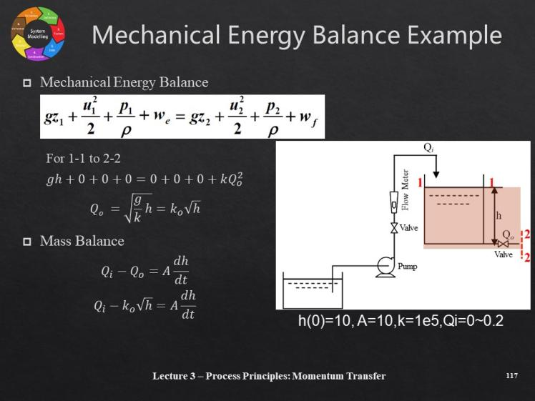

1. **Implementation**

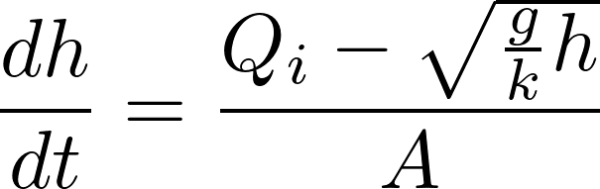

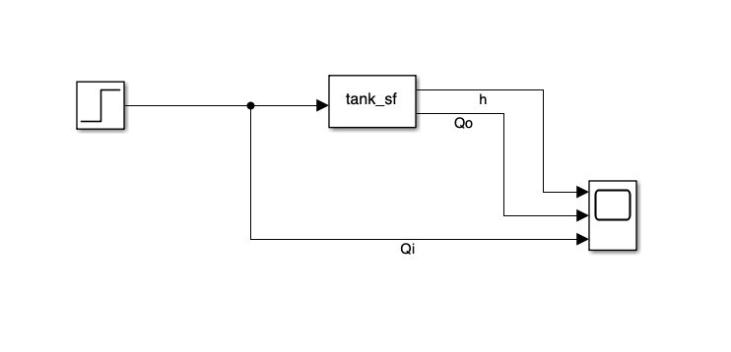

(For whatever the reason MATLAB 2023a differs from the previous editions concerning the implementation of calling for function template, which has changed into msfuntmpl instead of sfuntmpl with some minor modification on frame rate issues, i.e. )

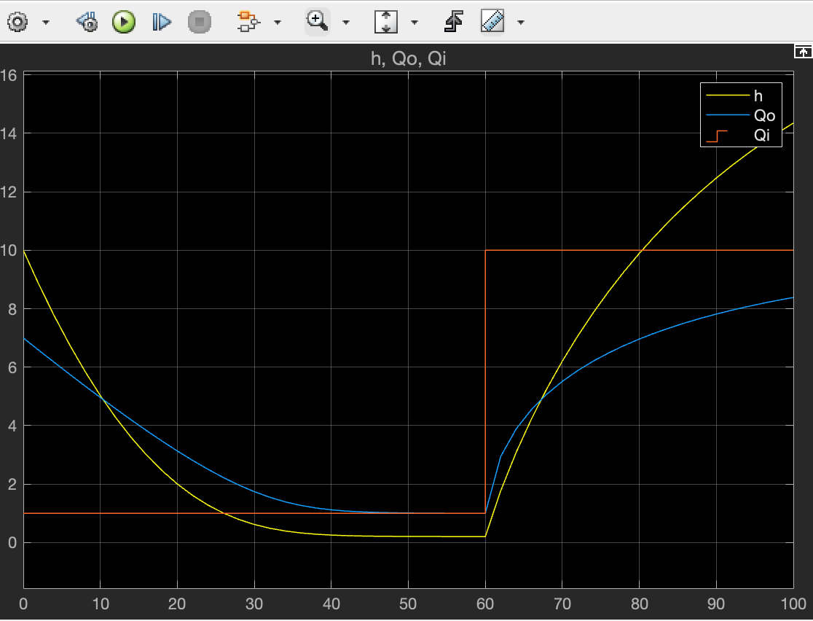

(Qi = 1->10 m3/s)

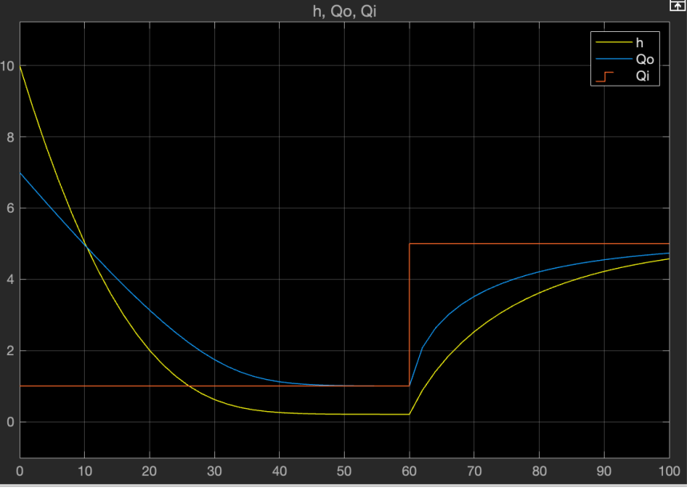

(Qi = 1->5 m3/s)